 | CAROLINA FIREBALLS  12U DEVELOPMENT SOFTBALL ORGANIZATION  Cary, North Carolina | Now Forming
LOOKING FOR PLAYERS & COMMUNITY SPONSORS
A positive, structured softball environment built to help young athletes gain confidence and love the game more.
WHY FIREBALLS?  ✓ Development over favoritism: Every player deserves coaching attention and opportunities to grow.  ✓ Fundamentals first: Throwing, catching, fielding, hitting, baserunning, and softball IQ.  ✓ Confidence building: Mistakes are teaching moments, not reasons to lose belief.  ✓ Structured practices: Positive, disciplined practices with a clear plan every time.  ✓ Developmental but competitive: Mostly local Triangle-area tournaments with occasional in-state play. | 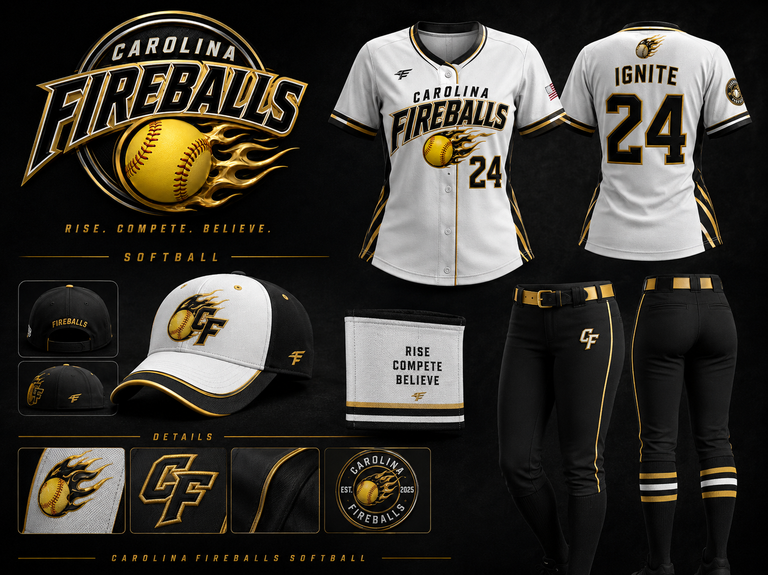
PLAYERS  12U athletes ready to grow | FAMILIES  Positive, team-first culture | SPONSORS  Support local girls softball
PROGRAM SNAPSHOT  • 2-3 practices per week during active training periods  • Target roster of 12-14 players  • Year-round program with natural lighter periods  • Few meaningful community volunteer opportunities | INTERESTED?  Email us for player interest, sponsorship opportunities, or more information.  Scan for website    carolinafireballs.org
Carolinafireballssoftball@gmail.com
RISE. COMPETE. BELIEVE.
carolinafireballs.org

