
CAROLINA FIREBALLS
12U PLAYER & PARENT PROPOSAL
A development-first softball organization based in Cary, North Carolina

Our Promise to Families
Carolina Fireballs is being built for families who want their daughter to gain confidence, love the game more, and grow through structured, positive, fundamentals-first softball development.

This guide is written for interested families. It explains what Carolina Fireballs is, who the program is best suited for, what the commitment may look like, how costs will be approached, and what families can expect from the team culture.

Welcome to Carolina Fireballs
Carolina Fireballs is a new 12U travel softball program based in Cary, North Carolina. The program is designed for families who want a serious but positive softball experience: competitive enough to challenge players, structured enough to help them improve, and supportive enough to help them build confidence and keep loving the game.
The organization will be led by Coach Sandra Arnold, whose background includes more than 20 years as a paramedic, youth baseball coaching experience, and a lifelong connection to softball as a player and coach. The program is built around development over favoritism, hard work, confidence building, and fundamentals first.
The Heart of the Program
A Carolina Fireballs player should leave the season not only as a better softball player, but as a more confident young person who loves the game more than when she started.

Why Families Would Choose Carolina Fireballs
- A development-over-favoritism culture where players receive real coaching attention.
- A fundamentals-first approach to throwing, catching, fielding, hitting, baserunning, and softball IQ.
- A positive but structured practice environment that teaches discipline without intimidation.
- A year-round development mindset with balanced expectations for school, family, and life.
- A team culture focused on confidence, effort, accountability, sportsmanship, and joy in the game.

Team at a Glance
Category | Parent-Facing Answer
Organization | Carolina Fireballs Softball
Age Group | 12U
Home Base | Cary, North Carolina
Program Type | Developmental but competitive travel softball
Target Roster Size | Approximately 12-14 players
Tournament Approach | Primarily local Triangle-area tournaments with occasional in-state travel when appropriate
Practice Approach | Structured, disciplined, positive, and encouraging
Core Message | Help players gain confidence and love softball more

Best Fit Player & Family
Carolina Fireballs is a strong fit for families looking for a serious but balanced softball experience. The program is designed for players who are ready to grow beyond rec ball, players who need more structure and confidence, and competitive players who want development without toxic travel-ball politics.
- Players who want to work, learn, compete, and improve.
- Families who value coaching, effort, confidence, and character development.
- Athletes who can handle structure while still needing encouragement and teaching.
- Parents who want a team-first environment rather than a politics-first environment.

Expected Commitment
Carolina Fireballs is intended to operate as a year-round development program with natural lighter periods built into the calendar. During active training periods, families should expect approximately 2-3 practices per week and 1-2 tournaments per month during tournament seasons.
Area | Expectation
Practices | Approximately 2-3 practices per week during active training periods. Practices may include indoor and outdoor work depending on facility access and season.
Tournaments | Approximately 1-2 tournaments per month during tournament seasons, especially once the team is formed and ready to compete.
Travel | Mostly Triangle-area tournaments in Year 1, with occasional in-state travel when appropriate. Overnight travel should be limited early.
Family Balance | The program will be serious and structured, but should recognize that athletes are still young and have school, family, and life outside softball.

Season Structure
The season should be presented as a year-round team with balanced expectations. Spring and summer would serve as the primary tournament season, fall may include development and selected tournaments, and winter can focus on indoor training, fundamentals, strength, movement, and preparation for the next season.

Costs & Financial Philosophy
Final player costs will depend on roster size, sponsorship support, fundraising success, tournament schedule, uniform package, facility access, and coaching/instruction needs. Carolina Fireballs should avoid locking families into an exact number too early, while still being transparent about the types of expenses families can expect.
Cost Philosophy
The goal is to keep costs as low as possible, communicate expenses clearly, and use sponsorships and fundraising to reduce the financial burden on families whenever possible.

Cost Area | Parent Explanation
Potential Player Costs | Final cost to be determined based on sponsorships, roster size, tournament schedule, uniforms, and facility access.
Sponsorship Impact | Sponsorships are intended to reduce family costs and help provide better training opportunities.
Fundraising | A few team fundraising events may be planned during the year, but fundraising should not overwhelm families.
Transparency | Families should receive clear explanations of what dues cover before making a commitment.

Program Cost Drivers
Parents do not need a full operating budget, but they do need to understand where money goes. A parent-facing proposal should include a simple summary of the major cost drivers.
Cost Driver | What It Supports
Indoor/Outdoor Facility Access | Practice fields, batting cages, indoor training, winter development
Tournament Fees | Team registration for local and in-state tournaments
Uniforms & Player Gear | Home jersey, alternate jersey, practice shirt, socks, belt, and optional team apparel
Equipment & Training Aids | Balls, tees, nets, catcher gear, fielding aids, training tools
Insurance & Registration | Team insurance, sanctioning, administrative requirements
Coaching & Instruction | Assistant coaches, specialty instruction, clinics, pitching/catching/hitting support when available

Player Development Model
Carolina Fireballs should be positioned as a development-first softball program. The focus is not simply on forming a team and entering tournaments. The focus is on helping each player build fundamentals, confidence, softball IQ, and competitive habits.

Softball Development
- Throwing mechanics and arm care habits
- Catching, receiving, and securing the ball
- Fielding fundamentals and footwork
- Hitting development and approach at the plate
- Baserunning and game awareness
- Situational softball and communication

Mental & Character Development
- Confidence through preparation and repetition
- Resilience after mistakes
- Positive communication with teammates and coaches
- Accountability without fear
- Leadership, effort, and sportsmanship

Athletic Development
- Speed and agility
- Coordination and movement quality
- Conditioning appropriate for age and season
- Injury-prevention habits and safe mechanics

Practice Environment
Practices will be structured, disciplined, positive, and encouraging. Players should know there is a plan every time they step on the field, while also feeling supported, taught, and motivated rather than intimidated.
Practice Component | Purpose
Warmup & Movement | Dynamic warmup, movement prep, throwing readiness
Throwing Progression | Mechanics, footwork, accuracy, arm care habits
Defensive Stations | Ground balls, fly balls, footwork, position-specific skills
Hitting Stations | Tee work, front toss, approach, mechanics, confidence
Situational Softball | Where to go with the ball, communication, baserunning, game awareness
Competition/Wrap-Up | Short competitive drill, team message, practice takeaways

Mistakes Are Teaching Moments
Players will be corrected, coached, and challenged, but mistakes will be treated as part of the learning process. The goal is to help players understand the adjustment and build confidence rather than fear failure.

Playing Time, Positions & Player Roles
Carolina Fireballs is a development-focused program, but playing time must still be earned through attendance, effort, attitude, coachability, and team needs. Every player should receive meaningful opportunities to grow, especially early in the season, but tournament playing time will not be guaranteed equally. The promise is that no player will be ignored, buried, or written off.
Players may have primary positions, but Carolina Fireballs will encourage athletes to learn multiple roles when appropriate. Position assignments will be based on skill, safety, effort, coachability, development needs, and what helps the team compete. Players may express position preferences, but final decisions will be made by the coaching staff. Pitchers and catchers may require additional practice time and commitment outside regular team practices.

Year 1 Competitive Goals
In Year 1, Carolina Fireballs should focus first on building fundamentals, confidence, team chemistry, and softball IQ. The team will learn how to compete in travel softball and aims to be competitive locally, but the program will not chase trophies at the expense of player development or love of the game.
- Build a strong team culture.
- Develop consistent softball fundamentals.
- Teach players how to compete with confidence.
- Play primarily local tournaments to build experience.
- Grow the team without overwhelming families with travel or cost.

Parent Culture & Communication
Carolina Fireballs expects a positive, team-first parent environment. Parents should support all players, model respectful sideline behavior, trust the coaching process, avoid politics, and communicate concerns directly and respectfully.
Communication Area | Standard
Team Updates | A team app or group messaging system should be used for schedules, updates, reminders, and tournament details.
Player-Specific Concerns | Families should communicate directly and respectfully with the coaching staff.
Playing Time Conversations | Playing time concerns should not be discussed immediately after games or tournaments. A cooling-off period and scheduled conversation should be used.

Academics, Community & Coaching Support
School comes first. Carolina Fireballs expects players to put effort into the classroom, maintain good academic habits, and understand that being a well-rounded athlete includes responsibility away from the field. Coaches will reinforce accountability and character, while parents remain responsible for managing academic expectations at home.
The team will look for a few meaningful volunteer opportunities during the year. The goal is to teach leadership, gratitude, and community connection without overwhelming families or turning service into another major time burden.
Carolina Fireballs will be led by Coach Sandra, with additional assistant coaches, parent volunteers, and specialty instructors added when appropriate. Parent volunteers may support stations, warmups, and team logistics, while pitching, catching, or hitting instructors may be used when available. The coaching staff will continue to grow as the program grows.

Uniforms, Gear & Team Identity
The final player gear package will depend on cost, sponsorship support, and vendor options. Expected items may include a home jersey, alternate jersey, practice shirt, socks, belt, and optional team apparel such as a hoodie or warmup. Some equipment, such as helmets, fielding masks, gloves, bats, cleats, and bags, may remain family-provided.
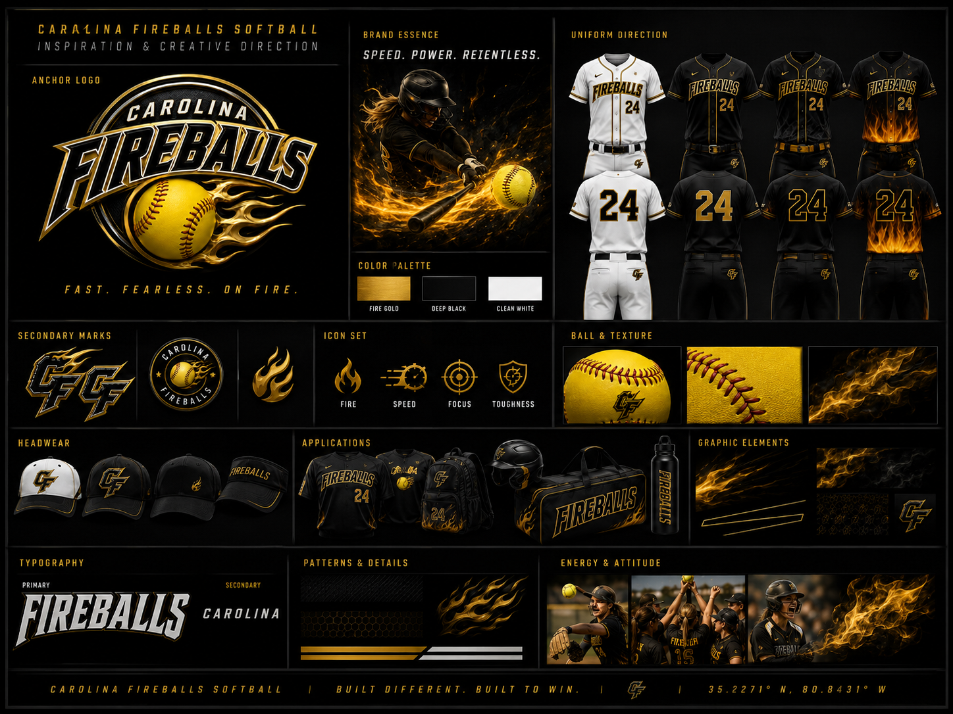
Brand direction: black, gold, white, and softball-focused identity system.

Tryouts & Team Selection
Carolina Fireballs will evaluate players on softball skills such as throwing, catching, fielding, hitting, running, and game awareness, but coachability, attitude, effort, and team fit will matter just as much as raw talent. The goal is not simply to choose the most polished players, but to build the right team culture with athletes who want to work, learn, compete, and grow together.
Tryout Area | What Families Should Know
Evaluation Areas | Throwing, catching, fielding, hitting, baserunning, athletic movement, softball IQ
Culture Fit | Effort, attitude, coachability, teammate behavior, willingness to learn
Roster Target | Approximately 12-14 players
Selection Philosophy | Build the right team, not simply collect the most polished players

Parent FAQ
Is this a serious travel team?
Yes. Carolina Fireballs is intended to be structured and competitive, but not at the expense of confidence, development, or joy in the game.
Will every player get equal playing time?
Not guaranteed. Playing time will be development-focused but must be earned through attendance, effort, attitude, coachability, skill development, and team needs.
How much will it cost?
Final costs will depend on sponsorships, fundraising, roster size, tournament schedule, uniforms, and facility access. The goal is to keep costs reasonable and communicate clearly.
How much travel should we expect?
Year 1 should be mostly local Triangle-area tournaments with occasional in-state travel when appropriate. Overnight travel should be limited early.
Can my daughter play multiple positions?
Yes, when appropriate. Players may have primary positions, but the program will encourage multi-position development based on safety, skill, effort, and team needs.
What if my daughter makes mistakes?
Mistakes will be treated as teaching moments. Players will be corrected and challenged, but the goal is to build confidence and learning, not fear failure.
What role do parents play?
Parents are expected to support the team culture, communicate respectfully, avoid sideline negativity, and help create a positive environment for all players.

Closing Message to Families
Why Join Carolina Fireballs?
Join Carolina Fireballs if you want your daughter to be coached, challenged, supported, and encouraged in an environment where confidence and love of the game matter as much as competition.

Carolina Fireballs is being built for families who believe youth softball should help girls become stronger players and stronger people. The program will compete, but its foundation will be confidence, fundamentals, teamwork, accountability, and joy.
Carolina Fireballs
12U Development Softball Organization
Cary, North Carolina

