CAROLINA FIREBALLS
12U DEVELOPMENT SOFTBALL ORGANIZATION
Sponsorship & Program Proposal
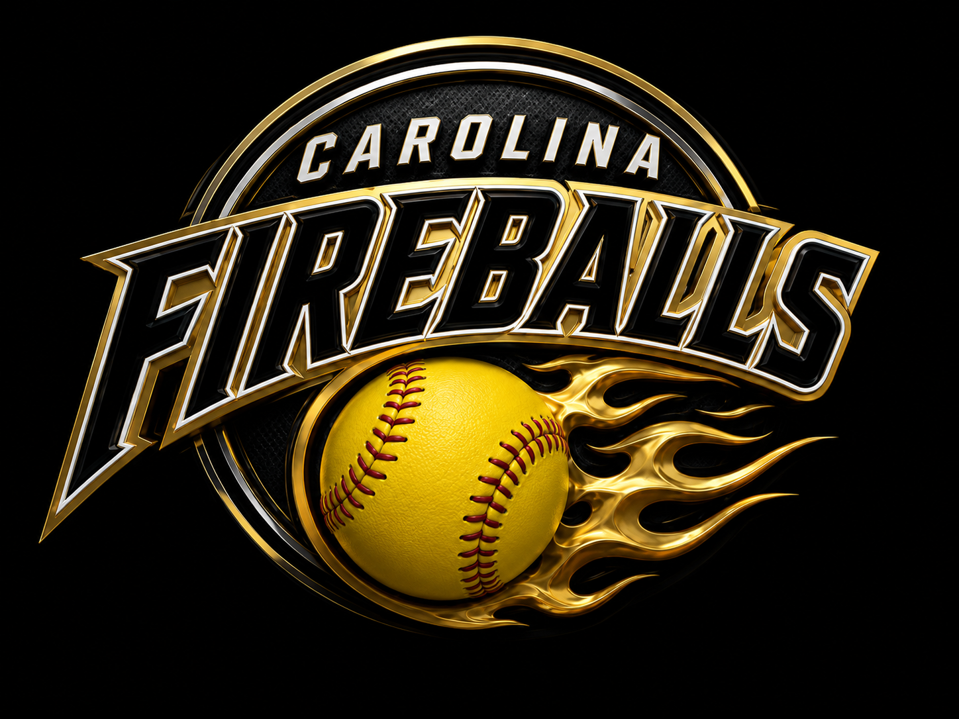
Carolina Fireballs Softball primary mark
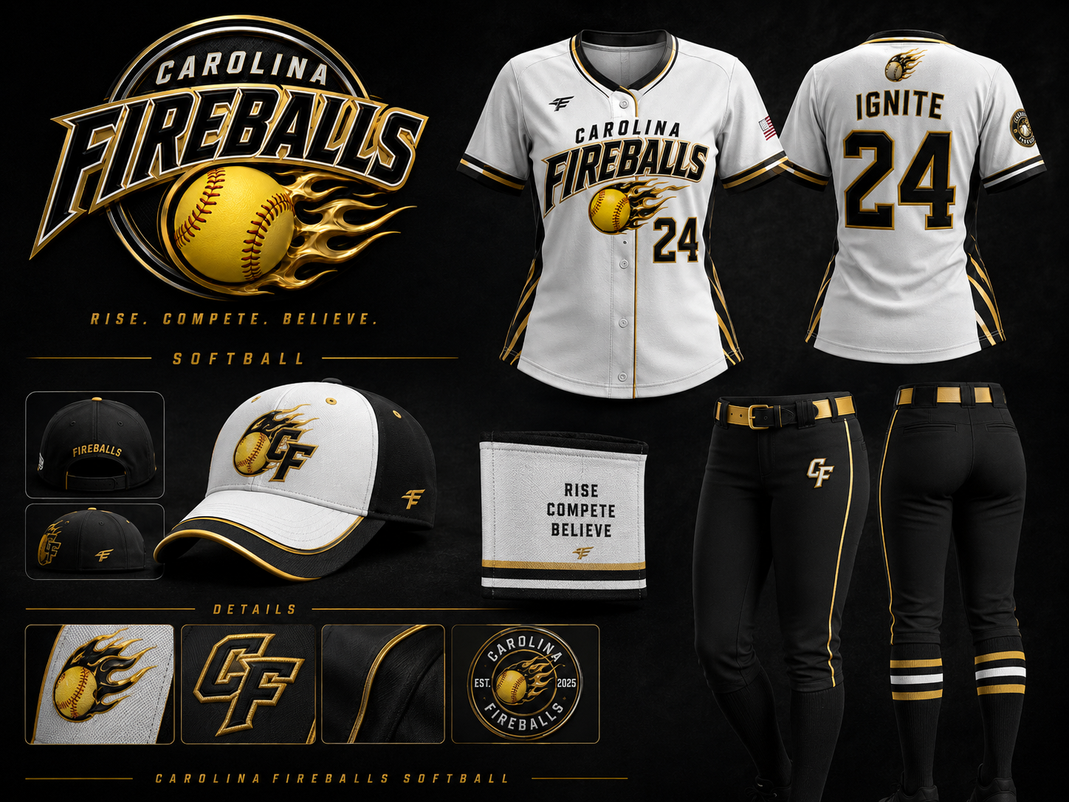
Program branding, apparel, and identity applications

INTRODUCTION
The Carolina Fireballs are a newly formed 12U travel softball organization based in Cary, North Carolina focused on developing confident, hardworking young athletes through structured softball training, mentorship, teamwork, and community engagement.
The organization is led by Coach Sandra Arnold, a retired paramedic with over 20 years of service who has a lifelong passion for athletics, coaching, and youth development. Sandra previously coached youth baseball in Garner as both an assistant coach and head coach while helping develop her son throughout his baseball journey. She also played softball competitively through middle school, high school, recreation leagues, and travel ball.
After years away from the game while focusing on family and career responsibilities, Sandra returned to coaching youth softball in Cary and quickly rediscovered her passion for helping young athletes grow both on and off the field.
The Carolina Fireballs were created to provide a positive alternative to the increasingly political and high-pressure environment often associated with travel softball. Our organization is built around development over favoritism, confidence building, hard work, and fundamentals-first coaching.
We believe softball should:
• Build confidence
• Teach discipline
• Create lasting friendships
• Empower young female athletes
• Develop leadership and teamwork
• Create joy through competition and growth
Our goal is to create an environment where athletes can compete, develop, and most importantly enjoy the game while building life skills that extend far beyond the softball field.

OUR MISSION
The mission of Carolina Fireballs is to develop fundamentally strong, confident, and empowered young female athletes through structured coaching, positive mentorship, competitive softball, and community involvement.
We strive to create:
• A development-over-favoritism culture
• A fundamentals-first training environment
• A positive and structured team atmosphere
• Opportunities for athletes of all backgrounds
• A program that builds character as much as athletic ability

OUR CORE VALUES
Development Over Favoritism
Every athlete deserves quality instruction, opportunities to improve, and a coaching staff invested in their long-term growth.
Hard Work
We believe effort, preparation, and consistency create success both on and off the field.
Confidence Building
Young athletes thrive when they believe in themselves. Our goal is to help every player build confidence through preparation, encouragement, and achievement.
Fundamentals First
Strong fundamentals create strong athletes. We focus heavily on proper mechanics, softball IQ, situational awareness, and disciplined training habits.
Teamwork & Sportsmanship
We teach athletes how to support teammates, handle adversity, and represent themselves, their families, and their community with pride.

PROGRAM OVERVIEW
Organization Name: Carolina Fireballs
Age Group: 12U
Home Base: Cary, North Carolina
Team Type: Developmental but Competitive
Focus: Long-term player development and empowerment
Practices will be structured, instructional, and high-energy while maintaining a positive environment that encourages athlete growth. Athletes will participate in throwing progressions, defensive work, position-specific instruction, hitting stations, situational softball, conditioning, and team-building activities.
The organization plans to utilize both indoor and outdoor facilities to allow year-round development and consistent instruction.

PLAYER DEVELOPMENT MODEL
The Carolina Fireballs focus on complete athlete development through:
Softball Fundamentals
• Throwing mechanics
• Defensive fundamentals
• Hitting development
• Catching instruction
• Base running
• Situational softball IQ
Mental Development
• Confidence building
• Resilience
• Positive communication
• Leadership
• Accountability
Athletic Development
• Speed and agility
• Conditioning
• Injury prevention
• Coordination and movement training
Community & Character
• Volunteer opportunities
• Team service projects
• Leadership development
• Community involvement

COMMUNITY IMPACT
The Carolina Fireballs are committed to giving back to the local community. We believe young athletes should learn the importance of leadership, service, and supporting others.
Planned community involvement may include:
• Youth softball clinics
• Food bank support
• Fundraising events
• Assisting local recreation programs
• Supporting local charitable organizations
• Community volunteer opportunities
We want our athletes to grow not only as softball players, but also as leaders within their schools and community.

SPONSORSHIP OPPORTUNITY
Sponsoring the Carolina Fireballs is an opportunity to invest directly into youth athlete development, female empowerment, and positive community engagement.
Your sponsorship helps provide:
• Indoor training opportunities
• Tournament participation
• Training equipment
• Uniforms and player gear
• Safer practice environments
• Development opportunities for athletes
Sponsors may receive:
• Company logo placement on team materials
• Social media recognition
• Sponsor spotlight posts
• Banner placement at games and events
• Website recognition
• Community event visibility
Our goal is to create meaningful partnerships with local businesses that believe in supporting youth athletics and community development.

SPONSORSHIP LEVELS
Carolina Fireballs is seeking a small group of committed business partners who want to support youth softball, female athlete development, and a positive community-based sports program in Cary and the surrounding Triangle area. Instead of listing every operating expense, this proposal offers clear sponsorship levels that directly help fund uniforms, training access, tournament opportunities, equipment, team operations, and player development.
Sponsor term and renewal: Tier sponsorships are recommended as 12-month annual commitments. This gives smaller businesses a full-year sponsorship window while giving the team consistency for uniforms, banners, social media recognition, tournament visibility, and season planning. Sponsors should receive a renewal conversation approximately 30 days before the sponsorship period ends. For jersey, banner, or apparel placements, sponsor commitments should be finalized before those items are ordered.
Tier Level | Investment | Sponsor Recognition / Team Benefit
Top Tier Sponsor | $7,500 | Premier sponsor recognition. Highest visibility across sponsor materials, website, social media, team banners/events, and priority renewal opportunity. Best fit for a business wanting maximum association with the Carolina Fireballs mission.
Gold Tier Sponsor | $5,000 | Strong sponsor recognition. Logo placement on sponsor materials, website recognition, social media spotlight, and banner/event visibility when available. Supports meaningful player development and tournament access.
Community Tier Sponsor | $2,500 | Accessible local business partnership. Website recognition, social media thank-you post, inclusion on shared sponsor materials, and community partner recognition.
Sponsor benefits can be adjusted based on timing, available assets, and the needs of the business partner. The goal is to keep the proposal simple, professional, and approachable while creating real value for the team and the sponsor.

LONG-TERM VISION
The Carolina Fireballs aim to grow into a respected youth softball development organization within the Triangle area.
Future goals include:
• Expanding into multiple age groups
• Hosting camps and clinics
• Creating scholarship opportunities
• Building long-term sponsor partnerships
• Developing advanced player training systems
• Becoming a recognized development-first softball organization
Our vision is to create a softball organization where athletes feel supported, challenged, empowered, and inspired to become leaders both on and off the field.

CONCLUSION
The Carolina Fireballs are more than a travel softball team.
We are building a culture centered around:
• Confidence
• Hard work
• Fundamentals
• Leadership
• Community
• Empowerment
Our mission is to provide young female athletes with an opportunity to grow both as players and as individuals in a positive, structured, and competitive environment.
We appreciate your consideration and look forward to building meaningful partnerships that positively impact young athletes throughout our community.
Thank you for your support.
Carolina Fireballs
12U Development Softball Organization
Cary, North Carolina

BRAND IDENTITY & UNIFORM CONCEPTS
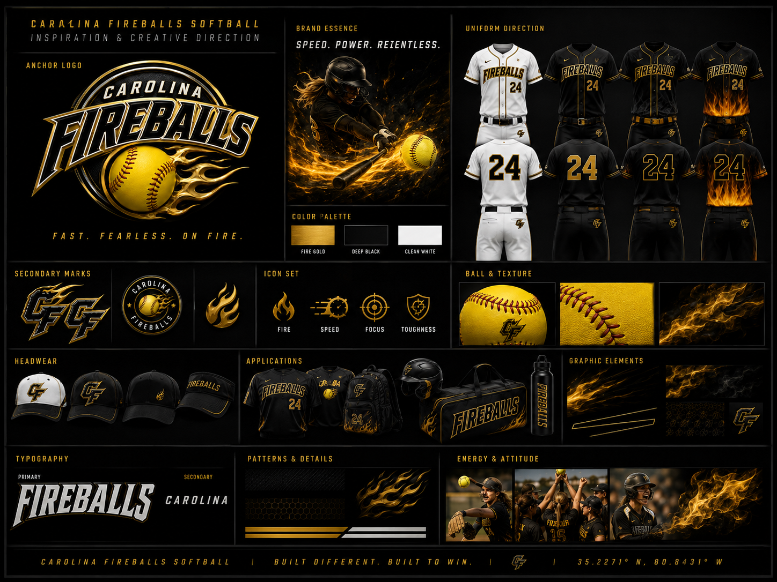
Creative direction board showing tone, energy, and team presentation
The Carolina Fireballs brand identity is designed to represent energy, empowerment, confidence, and competitive spirit while maintaining a clean and professional softball aesthetic. The visual branding system supports tournament visibility, community presence, social media engagement, and sponsor recognition.

UNIFORM & SPONSOR VISIBILITY
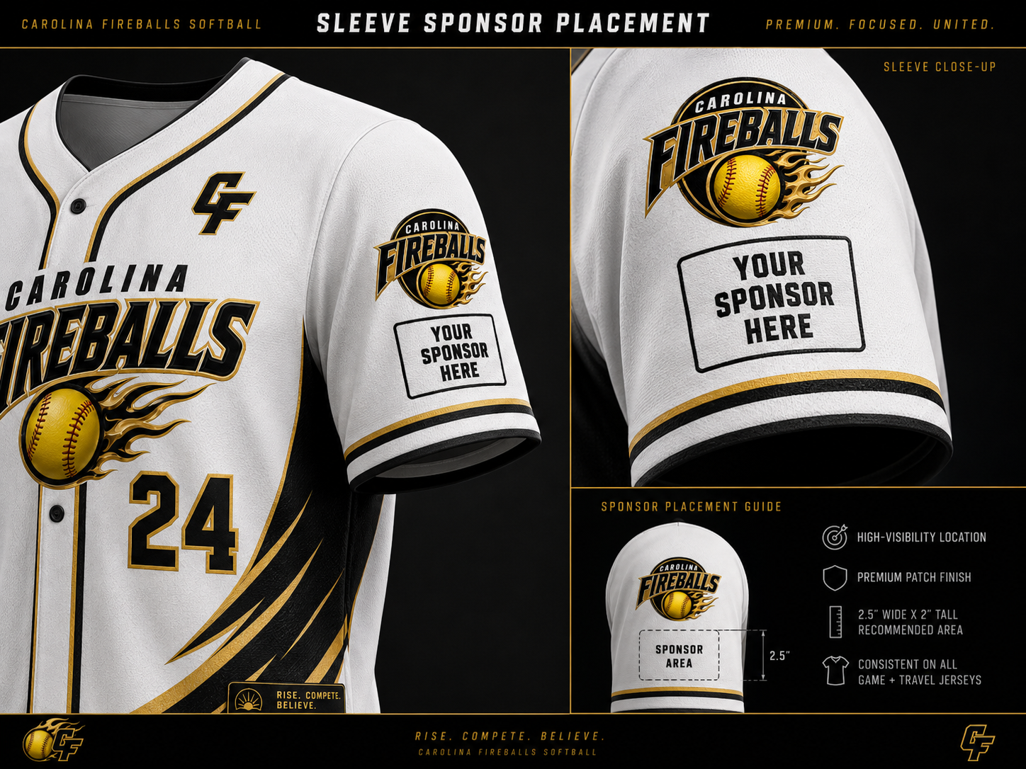
Clean sponsor placement concept for jersey sleeve branding
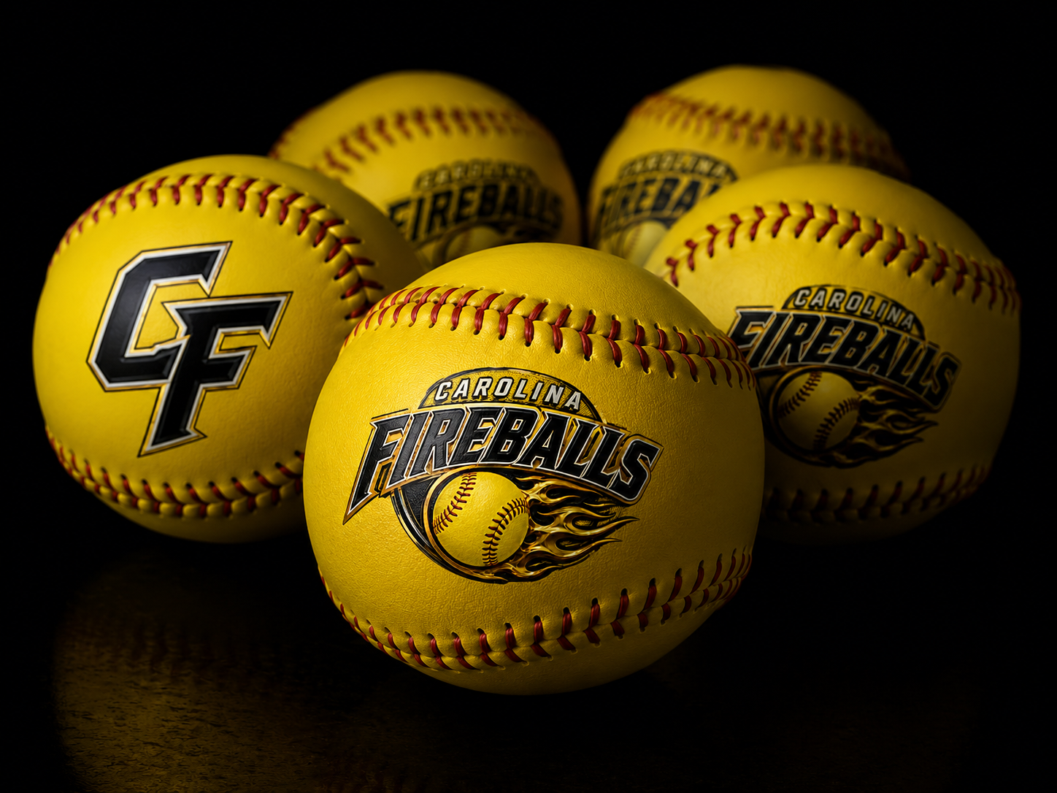
Additional branded equipment concept showing logo application on softballs
Potential jersey and apparel concepts are intended to create a recognizable and modern team identity while maximizing sponsor visibility throughout the season.
Branding applications may include:
• Home and away jerseys
• Tournament alternate uniforms
• Practice apparel
• Hoodies and warmups
• Team banners and field signage
• Sponsor-branded social media graphics
• Bat bags, helmets, and equipment branding
Sponsor logos may be featured on uniforms, banners, digital media, team materials, and community events to help create consistent visibility throughout the Triangle softball community.

Visit Carolina Fireballs Online
Scan the QR code below or visit carolinafireballs.org

https://carolinafireballs.org

